STRAWBERRIES AND CREAM TEA PARTY


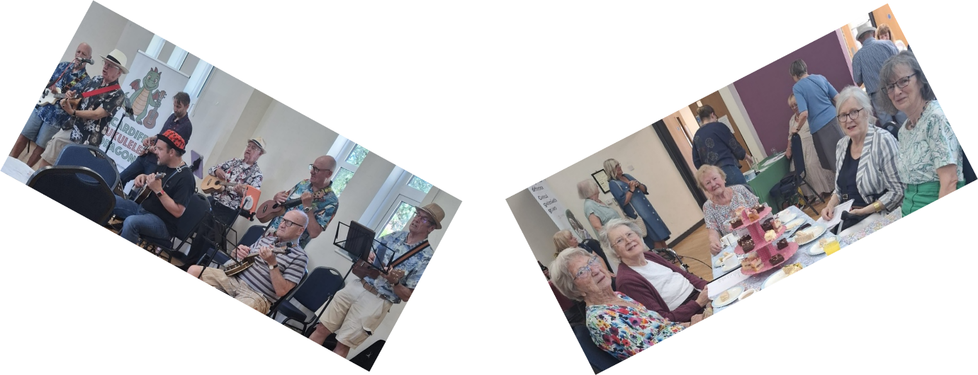
On July 2nd over 60 people attended the Annual GNINC Tea Party and an amazing £843 was raised through ticket sales, raffles and sponsorship

Rosemary Mathews, Chairperson of GNINC, said: “We are delighted to have been able to hold this event and see so many clients and volunteers enjoying an afternoon at Christ the King Parish Centre which is a super venue for such an event.”

The Cardiff Ukulele Dragons provided entertainment for our guests and everyone had a lovely afternoon. They all loved getting together and having a chat and a sing song, which is so important for everyone’s mental health well-being.

We held a raffle and with tea party ticket sales and the very generous sponsorship by Sainsbury’s Thornhill store and Finsbury Foods ( Memory Lane Cakes) helped the charity raised the money which will allow us to continue our Good Neighbour work in North Cardiff. Thank you from all involved.

