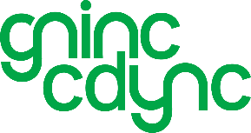

Good Neighbours in North Cardiff

My Community, Your Community, Our Community

Are you interested in helping run our charity’s day to day business?

It’s a very rewarding job.

We are looking for a new Administrator and the hours are 9.30am – 12.30am on Tuesday, Wednesday, and Thursday.

The remuneration for the 9 hours per week is paid at the National Living Wage of £12.21 hourly rate, set to increase on 1 April 2026 to £12.71.

Duties – the main role is to provide support to volunteers and clients by matching volunteers to the task required by our clients. The entire system is computerised, and the successful candidate will need to be familiar with the usual MS Office apps and will be given training on Volunteero app along with general office procedures. The nature of the post will require the successful candidate to observe confidentiality and adhere to our GDPR and Safeguarding policies.

Line management is via our Operational Co-Ordinator Julie who has a hybrid work pattern so is not always in the office. Therefore, you should be comfortable to work alone as well as part of a small team. To arrange an informal discussion please contact Julie via email operations@gninc.org.uk or call 029 2075 0751

