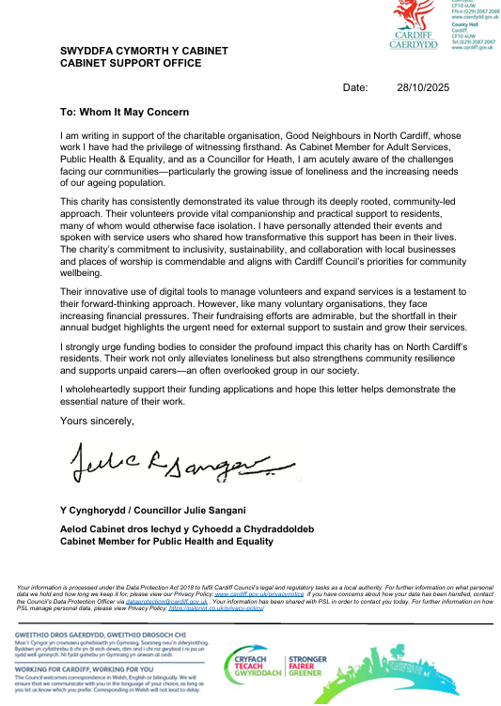
etters of Support
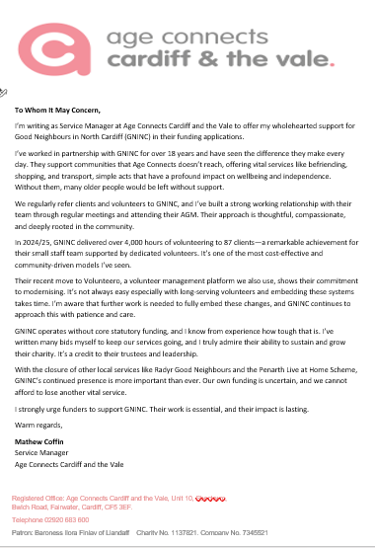
To Whom it may Concern,

I write to support The Good Neighbours in Cardiff North GNINC. Cardiff North has an ageing population and GNINC provide essential services to address wellbeing needs of over 65 year olds. They provide vital transport, shopping (Accompanied), face to face and over the phone befriending/ companionship services. With ageing population the need of these services is growing and so building capacity in provision is an ongoing challenge.

GNINC are also using technology to ensure they utilise digital platforms to operate smartly and efficiently and maximise their reach and impact. Support is needed to maintain such digital platforms and upgrade.

GNINC work well with the local authority and their services contribute to the commitment of local authority to the Wellbeing of future generations act and Ageing Well agenda.

Should you require any further information in support of GNINC please don’t hesitate to contact me.

Kindest Regards,
Cllr (Dr) Bablin Molik
Liberal Democrats Councillor for Cyncoed & Lakeside
Chair of Community and Adult Services Scrutiny Committee
Tel: 07779975394
Email: Bablin.Molik@cardiff.gov.uk
@BablinMolik

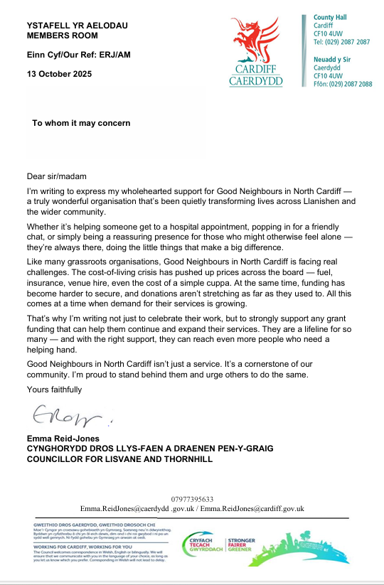
14th October, 2025

To whom it may concern

I am delighted to support the work of the organisation: Good Neighbours in North Cardiff
As a county councillor for the electoral ward of Cyncoed, I am aware of the important role Good Neighbours in North Cardiff play in the community across the north of the city.
I have had very positive contact with volunteers who help the organisation and with the staff who operate in a managerial position. I have had personal experience of contacting the organisation to seek support for an elderly local resident and was impressed by the professionalism, courtesy and willingness to help. The organisation provides a range of support services that can be adapted to meet the needs of the individual.
I am delighted to fully support the application they have made for further funding to both maintain the high quality service they provide at present and to enhance and modernise the service for the elderly and disabled in the future.

Yours faithfully,
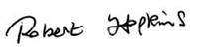

Cllr. Robert Hopkins
Ward councillor for Cyncoed and Lakeside.

We are writing as Local Councillors for the Llanishen Ward of Cardiff County Council to express our full support for Good Neighbours in North Cardiff.

The Organisation’s base is in the Llanishen Ward and we are fully aware of the significant work they do in the community especially providing help and support for vulnerable groups such as the elderly and disabled. They are an integral part of services to the client group concerned and we know from first hand, the impact their volunteers have on the lives of those they help. We have referred residents to GNINC ourselves and are in frequent contact with Chair Rosemary Matthews and other Officers over a wide range of issues.

We are aware of the close contact the Organisation has with a wide range of groups in the community especially local churches and, recently, GNICN have provided a presence at our newly opened Llanishen Repair Shop in the local Church Hall.

We are fully aware of the considerable achievements the Organisation has achieved already. We have been pleased to attend their Annual Meeting and social events and we are aware of their ambition to continue their great work and to both expand geographically and to enhance the service they provide even more. In order for them to do so, they will need investment in IT and funding to help their network of Volunteers to provide a service for an ever increasing client group.

Cllr Garry Hunt Cllr Bethan Proctor
07977470363 07977395643
G.Hunt@cardiff.gov.uk B.Proctor@cardiff.gov.uk

